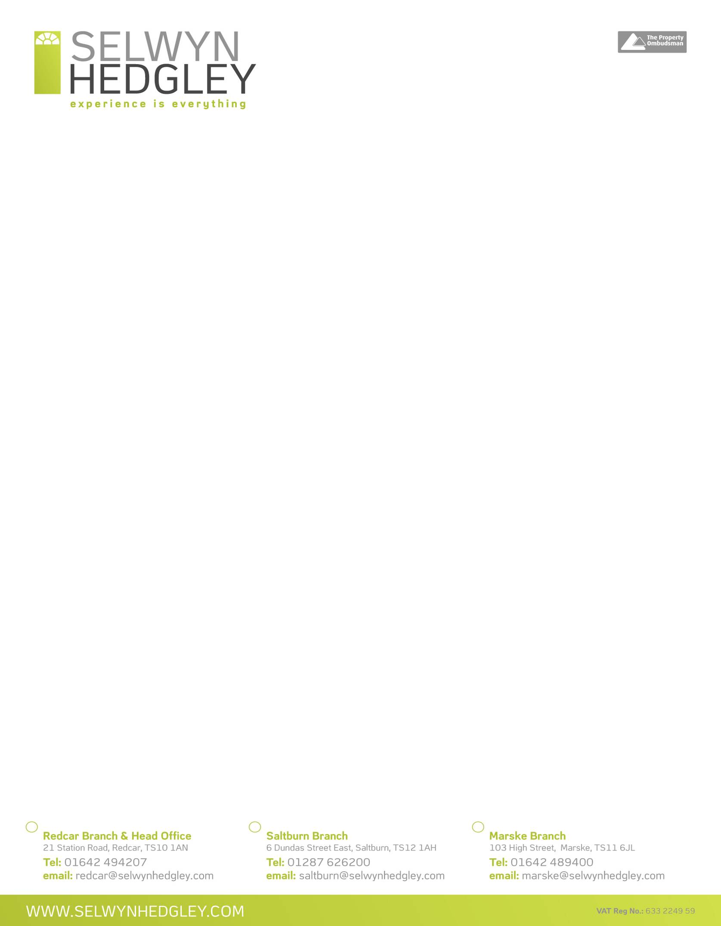

Selwyn Hedgley Estate Agents

6 Dundas Street East

Saltburn

Cleveland

TS12 1AH

01287 626200

saltburn@selwynhedgley.com

MEMORANDUM OF SALE

SUBJECT TO FORMAL WRITTEN CONTRACT

# AMENDED SALES DETAILS

Ref: GW/KR

Date 23rd March 2021

PROPERTY82 Wilton Bank, Saltburn, Cleveland TS12 1NU

AGREED OFFER: £156,500 (One Hundred & Fifty Six Thousand, Five Hundred Pounds)

LOCAL AUTHORITY: Redcar & Cleveland Borough Council

VENDOR(S) Mr Steve & Miss Susan Taylor

ADDRESS: Fernbank House, Bamff Road, Alyth, Blairgowrie, Perth And Kinross, PH11 8DT

SOLICITORS Cygnet Law

ADDRESS: Portland House, West Dyke Road, Redcar, Cleveland TS10 1DH

TELEPHONE: 01642 777680

EMAIL: kbrown@cygnetlaw.co.uk

CONTACT: Kristee Brown

PURCHASERS: Mr Clive & Mrs Lynn Corner

ADDRESS: 21 Cliffton Common, Brighouse, West Yorkshire HD6 1QW

SOLICITORS: Macks Solicitors

ADDRESS: 4 Woodlands Road, Middlesbrough TS1 3AY

TELEPHONE: 01642 252828

EMAIL: jane.carey@macks.co.uk

CONTACT: Jane Carey

CHAIN It is our understanding that the purchaser is in a position to proceed.

EPC Reference: 9380-2735-7020-2300-4201

.